Design Document
(version 1.0)
Team-5

Created On: 17th March, 2011

CONTENTS

- Introduction…………………………………………………………………………………………3

- System Architecture…………………………………………………………………………….4

- Detailed Description of Components……………………………………………………5
  - Data Flow diagram………………………………………………………………..5
  - Class Diagram……………………………………………………………………….6
  - Collaboration diagrams…………………………………………………………7
  - ER diagram……………………………………………………………………………10

- User Interface Description ………………………………………………………………….11
  - Use case diagram………………………………………………………………….11
  - Use case Description…………………………………………………………….12
  - Activity Diagram…………………………………………………………………..17

- Introduction

This is a project meant to add an additional functionality to the existing zimbra client-server application. The main functionality of the product is to send an SMS to user for a mail received in the inbox with many other features including task reminders and appointment reminders. The basic design approach that is chosen is Object Oriented Approach.
This document starts by introducing the overall architecture of the system. It then presents various class diagrams, activity diagrams and others that describe the design in detail graphically.

2. System Architecture

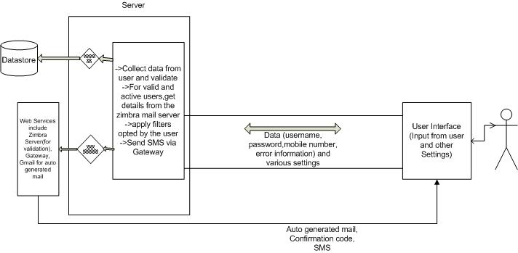

The picture shown above depicts the architecture of the system.

The user input is verified on the server side. It the inputs are invalid, the user would be informed about the same. However, if the details input by the user are correct, the server would register the user and a confirmation code would be sent on the supplied number via an SMS.
Once the user is registered, the server application would Poll the zimbra server and filter the mails in accordance with settings made by the user. SMSs are then sent via a gateway.

- Detailed Description of Components

- Data Flow Diagram:

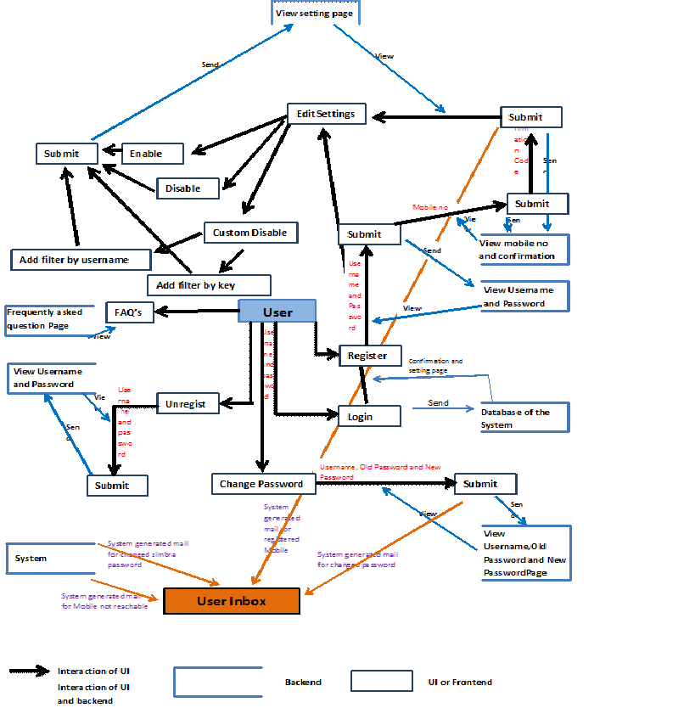

- Class Diagram

The following is the class diagram depicting the relationship between various classes.

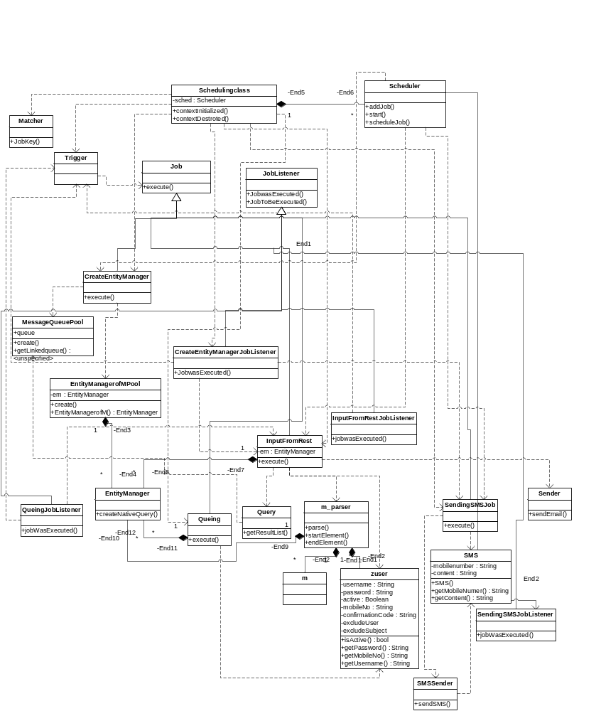
- Collaboration diagrams:

Getting unread mails and putting them into the data store.

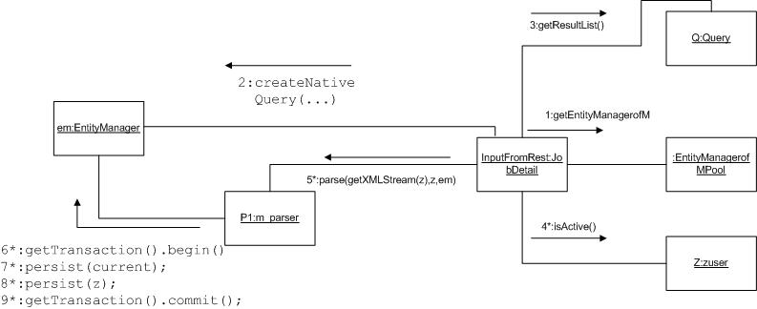

Putting objects from data store into Queue: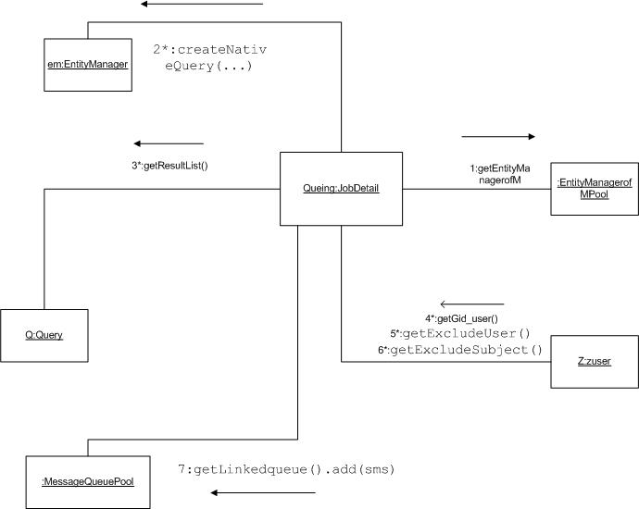

Sending SMS:

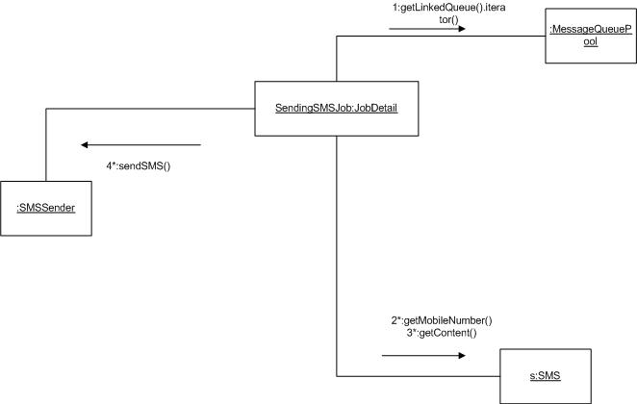

- ER diagram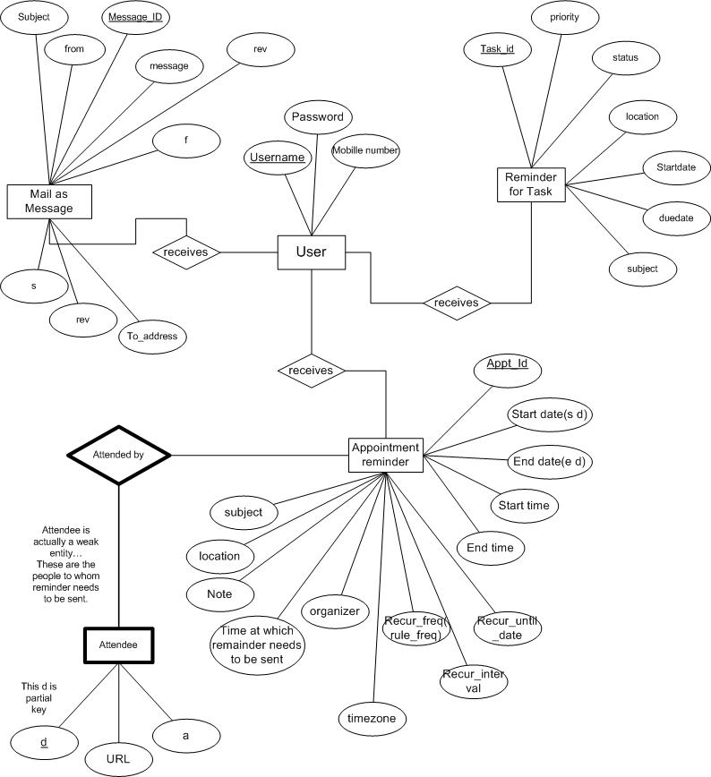

- User Interface Description

- Use case Diagram

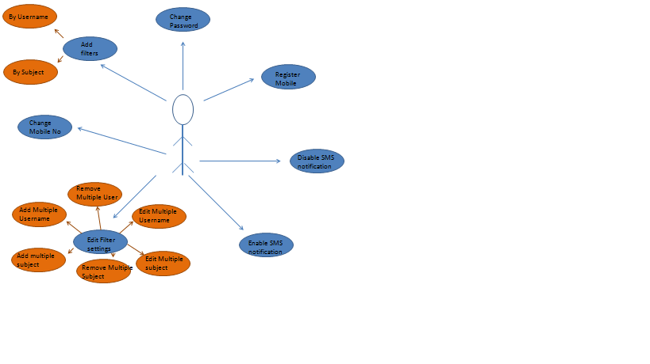

b) Use case Description
Name of the Case | View MNC Page for registration for new account
Description | User can view the MNC Login page
Pre-condition | User has to logged in the zimbra desktop
Post-condition | A MNC page asking for the Username, Password and a submit button will be displayed on new page
Normal flow of the event | - User selects the SMS setting on the extreme left of your zimbra home page  - Then click on the register button
Alternate flow the event | None

Name of the Case | Entering Username and Password to register
Description | User has to enter Username and Password as the first step for registration
Pre-condition | User has to open the SMS setting page (MNC) and clicked on the register button
Post-condition | When Username and Password pair is given a new page will appear asking for mobile number
Normal flow of the event | - Left click on the Username Text Box  - Enter the Username  - Left click on the Password Text Box or press Tab button  - Enter the Password  - Click on the Submit button
Alternate flow the event | None

Name of the Case | Registering Mobile Number
Description | Registering for the Mobile on which user want the notifications
Pre-condition | User has to enter pair of Username and Password in the previous page
Post-condition | If correct confirmation code is entered then a new page asking for the change in the settings will appear else a request for entering the correct confirmation code will be displayed
Normal flow of the event | - Click on the Mobile Number Text Box  - Enter the mobile number  - Click on the submit button  - A confirmation code will be send on the mobile whose number you have entered  - Click on the confirmation code Text box  - Enter the confirmation code  - Click on the submit button
Alternate flow the event | None

Name of the Case | Keeping the default settings
Description | User will get the notification of all the Email he receives in the zimbra webmail
Pre-condition | User has already register his mobile for the notification
Post-condition | Zimbra desktop will be displayed back
Normal flow of the event | - Select the enable radio button  - Click on the apply button
Alternate flow the event | None

Name of the Case | Viewing the custom disable setting for manual settings
Description | SMS setting page will be displayed
Pre-condition | User has already register his mobile for the notification
Post-condition | A new page containing the feature of SMS notification will be displayed
Normal flow of the event | - Click on the custom radio button
Alternate flow the event | If the user has already registered for the SMS notification then the page for SMS setting will appear directly after logging in MNC page

Name of the Case | Adding filter by the Username
Description | User can add various username in order to filter their notification via SMS
Pre-condition | User has already register his mobile for the notification and User has selected the custom disabling button on the setting page of MNC
Post-condition | List of all the username will be displayed whose SMS notification has to be filtered
Normal flow of the event | - Click on the Add button under the username text box  - Enter the username  - Click on the add button to enter another username and so on  - Click on save button
Alternate flow the event | None

Name of the Case | Adding filter by the string in the subject
Description | User can add various string in order to filter their notification via SMS whose subject does not contain that string
Pre-condition | User has already register his mobile for the notification and User has selected the custom disabling button on the setting page of MNC
Post-condition | List of all the strings will be displayed whose SMS notification has to be filtered according to that string in the subject
Normal flow of the event | - Click on the Add button under the filter by subject text box  - Enter the key word  - Click on the add button to enter another keyword and so on  - Click on save button
Alternate flow the event | None

Name of the Case | Applying for the settings entered for the filters
Description | User can apply the settings which he has entered in the SMS setting page.
Pre-condition | User has to fill the SMS setting page according to their needs
Post-condition | Zimbra desktop will be displayed back
Normal flow of the event | - Click on the save button to apply for the changes.
Alternate flow the event | None

Name of the Case | Viewing the SMS setting page if the user has already registered
Description | Viewing the SMS setting page directly if the user has already registered
Pre-condition | User has to logged in to their zimbra mail account
Post-condition | SMS setting page will be shown
Normal flow of the event | - User selects the SMS setting on the extreme left of your zimbra home page.  - User has to enter username and password for the MNC page.
Alternate flow the event | None

Name of the Case | Disabling the SMS notification
Description | This allow the user to disable the notification feature if it is enabled
Pre-condition | User has to logged in their zimbra mail account and logged in the MNC page
Post-condition | SMS setting page will be shown
Normal flow of the event | - User selects the SMS setting on the extreme left of your zimbra home page.  - Then enter the username and password to login the MNC account.  - Select the Disable radio button.  - Click on submit button.
Alternate flow the event | When user register their mobile for the first time

Name of the Case | Changing the mobile number
Description | When user has to change the mobile number in order to get the notification on new mobile
Pre-condition | User has to be in the login page of the MNC
Post-condition
Normal flow of the event | - Click on the Unregister button.  - Enter Username and Password.  - Click Submit button.  - Re-register with the new mobile number (steps in previous use case).
Alternate flow the event | None

Name of the Case | To unregister the MNC account
Description | To delete the MNC account
Pre-condition | User has to be on the MNC login page
Post-condition
Normal flow of the event | - User selects the SMS setting on the extreme left of your zimbra home page.  - Click on the Unregister button.  - Enter Username and Password.  - Click save button.
Alternate flow the event | None

- Activity Diagram

